**ExxonMobil Scheduling System**

**Final Report**

**October 11th, 2018**

**Team 2**

**Xinhui Zhang**

**Kevin Oula**

**Shriya Prabhu**

Table of Contents

**Abstract** **3**

**Functional Requirements** **3**

**Use Case Diagram** **4**

Use Case Description 5

**Sequence Diagram** **6**

**Class Diagram** **7**

**Transcript of the demo video** **7**

**List of usernames and passwords** **8**

# Abstract

# We have designed and implemented an interview scheduling system for Exxon Mobile’s user research team. Exxon Mobile’s interviewers and interviewees are the only users of the current prototype.

# Using graphical user interfaces (GUIs) we have implemented the following broad requirements: upload and schedule interviews, view existing interviews and cancel interviews. We will discuss these in the next section in detail.

# The user has to login to be able to use the software. After login, a user is presented with several choices to proceed. interviewers and interviewees see different options. For example, an interviewer can upload availability in addition to viewing existing interviews, and cancelling interviews. An interviewee can pick interview times, viewing existing interviews and cancel interviews. The data created about the interviews is stored in a database server.

# In his report, we discuss the functional requirements, relevant use cases, sequence diagrams, and the classes and associations necessary to implement the software. Because we are using a relational database in the backend, we will also provide a data model for completeness.

Glossary

User: The user can be either an interviewer or a an interviewee.

Schedule: Refers to the work schedule of the employee.

Interviewer: Person who created a schedule based on their availability for the interviewees to choose from.

Interviewee: Person who chooses from the schedule made available by the Interviewer Interview: A meeting arrangement made by the interviewer to meet the interviewee.

# Functional Requirements

* Allow the employee to log in.
* Allow the employee to be defined by the role (interviewer or interviewee) from the database.
* Allow the interviewer and interviewee to view existing confirmed appointments
* Allow the interviewer to upload availability..
* Allow the interviewer to cancel appointments. Cancelling an appointment will notify the interviewee on the other end.
* Allow the interviewer to upload and attach documents relevant to the interview.
* Allow the interviewee to be informed of interview requests.
* Allow the interviewee to cancel their appointments. Cancelling an appointment will notify the corresponding interviewer.
* Allow the interviewee to respond to the appointment request and confirm an appointment.
* All the information will be stored inside a database that will be accessed by both the interviewer and interviewee throughout the process.

# 

# Use Case Diagram

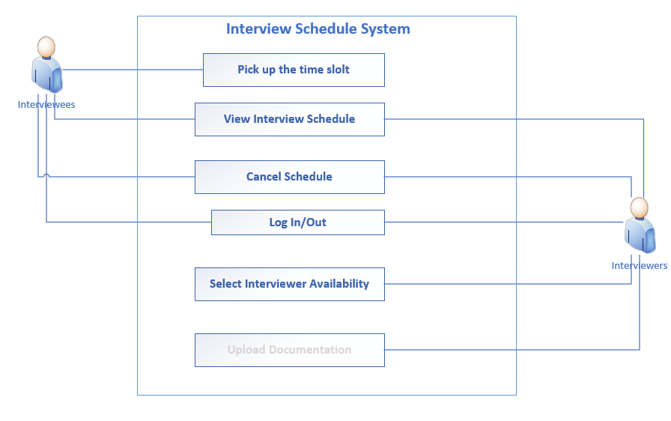

## Use Case Description

**Use case**: Scheduling an interview

**Actors**: Interviewer and Interviewee

**Goal**: To schedule an interview between and interviewer and interviewee based on availability

**Typical Course of Actions**

|  |  |
| --- | --- |
| **Actor Action** | **System Response** |
| 1.) Interviewer clicks “Upload Availability”. | 2.) System will open the availability form. This form will display a list of time slots that have been stored by the user. From this form, the user can upload or delete an availability. |
| 3.) Interviewer enters proper date, start, and end time, and then clicks “Confirm” to upload availability. | 4.) System reads the data entered and records the list of dates into the database. System will update the listbox to display the time slot and return a confirmation message. |
| 5.) Interviewee logs in and clicks “Pick Interview Time”. | 6.) System opens the choose interview form. This form displays the availabilities of the interviewer(s). This form allows the interviewee to confirm an appointment. |
| 7.) Interviewee selects an availability and confirms the appointment time. | 8.) System creates an appointment ID associated with the interviewee and interviewer(s). The form automatically returns the interviewee to the main page and prevents the him/her from creating another appointment. |

**Alternative Course of Action**

|  |  |
| --- | --- |
| 3a.) Interviewer deletes availability (loop back to 1) | If an appointment exists on that availability, the system will prevent the action and tell the interviewer that the appointment must be cancelled before the availability can be deleted. |
| 7a.) Interviewer/Interviewee cancels appointment (loop back to 5) | System deletes the appointment ID associated with the room, interviewer(s), and interviewee. Another appointment can be scheduled. |

# 

# Sequence Diagram

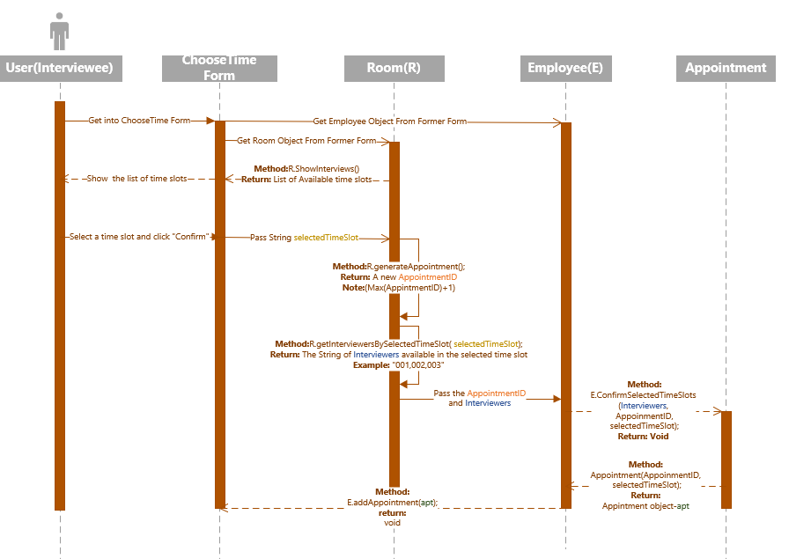

# Class Diagram

# 

# 

# 

# 

# 

# 

# Data Model

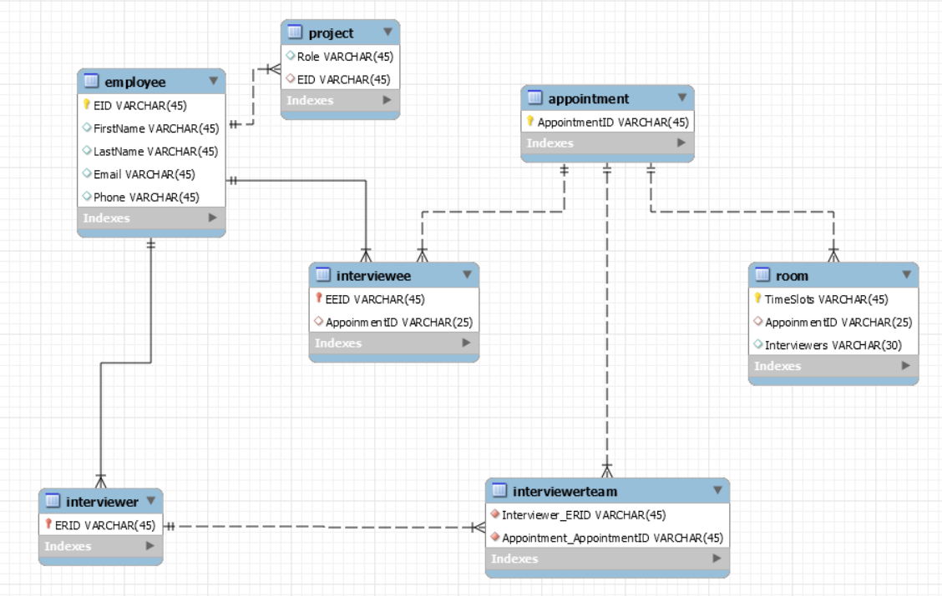

# Transcript of the demo video

Logging into the application is fairly simple. Enter the user’s username, password, and Employee ID. For this project, we did not handle the username and password because we were not sure how ExxonMobil distributes and handles their employee credentials. So we determined the role of the user based only on the Employee ID. IDs 001 and 002 refer to interviewers. IDs 003 and 004 refer to interviewees.

Using ID 001, we log in as interviewer 1. The main page has a message box that displays the interview status. This message changes based on how many interviews the interviewer has scheduled. The interviewer will first need to upload their availability. Availability is entered by submitting a date and a start and end time. The date is checked for the exact format yyyy/mm/dd and for realistic dates. Month must be >=1 and <=12. Day must be >=1 and <=31. For specific months, we ensure the dates are realistic too. For example, February 1st is not a real date. We also check that the end time is after the start time. Once all parameters have passed, we divide the availability into 30 minute time blocks. From this interface, the interviewer is also able to delete an availability. The only constraint to this is that that availability must not have an interview schedule at that time already. If so, that interview will need to be cancelled before the availability can be removed. Once everything is done, the interview can go back to the main page and logout.

Next, the interviewee must log in and select an interview time. Using ID 003, we login and select “Pick interview time”. Based on the availability that the interviewer has uploaded, the interviewee will be able to select one timeslot of their choice. Once an interview time has been confirmed, the form will create the appointment and return the interviewee to the main page. The main page’s interview status message will change to display that an interview has been scheduled, and the interviewee will be unable to pick another time. The appointment time can be viewed by clicking the “View My Interviews” button. This page exists and is functional for both the interviewer and interviewee. It shows all the confirmed interview times they have, and it allows both the interviewer and interviewee to cancel an interview if they need to. Canceling an interview will remove the appointment confirmation and allow the interviewee to reselect another time slot and the interviewer to remove the associated time slot from his/her availability.

If two interviewers have a common availability and the interviewee selects a time slot that matches both interviewers, then every user will have an appointment created for them. If any user with that appointment cancels it, then the system will also delete the appointment for each user.

# List of usernames and passwords

For the MySQL Database, the username is “ISOM6259”. The password is “ISOM6259”.

Below are the Employee IDs used at the login form to determine the role of the user.

|  |  |
| --- | --- |
| Employee ID | Role |
| 001 | Interviewer |
| 002 | Interviewer |
| 003 | Interviewee |
| 004 | Interviewee |